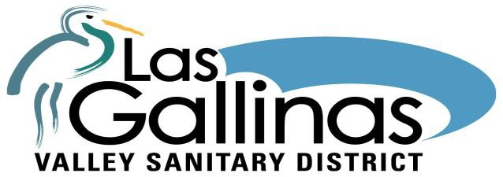

The Mission of the Las Gallinas Valley Sanitary District is to protect public health and the environment by providing effective wastewater collection, treatment, and recycling services.
DISTRICT BOARD
Megan Clark
Ron Ford
Craig K. Murray Gary E. Robards Crystal J. Yezman
DISTRICT ADMINISTRATION
Curtis Paxton
General Manager
Michael Cortez, District Engineer
Mel Liebmann, Plant Manager Greg Pease,
Collection System/Safety Manager
Dale McDonald,
Administrative Services Manager

Request to Speak Form

Welcome to the Las Gallinas Valley Sanitary District Board Meeting.
Please complete this form and hand it to the General Manager. During Zoom Meetings, please send to the Board Secretary – tlerch@lgvsd.org 3 hours prior to the Board meeting.

Name (PRINT):
Etiquette: Please be seated and wait to be called to speak. Begin by stating your name, city of residence, and whether you are speaking for yourself or on behalf of an organization. If you have handout materials, give them to the General Manager. You have three minutes to speak unless informed otherwise. After speaking, return to your seat in the Board Room.

City of Residence:

FOR TOPICS NOT ON THE AGENDA:
- I wish to speak during the Public Comment period.

FOR ITEMS ON THE AGENDA:
- I wish to speak on the subject of Agenda Item #

Optional - My comments will be (CIRCLE ONE): General For Against

- I do not want to speak; however, I would like to leave comments for the Board of Directors:

101 Lucas Valley Road, Suite 300 • San Rafael, CA 94903 • 415.472.1734 • Fax 415.499.7715 • www.lgvsd.org

